Assignment 3

Edge Detection, Line & Circle Detection, Matching Using Local Features & Template Matching

Part I: Edge Detection
Create a program (save as Assignment3_1). Include code to:
- Open ‘Credit’ image and convert it to greyscale. Paste the result here.

- Use OpenCV to find edge maps on the image. Use a Sobel operator. Display the results for the following parameters as well as two output datatypes, i.e., CV_8U and CV_64F. Paste results here.
- dx =1 , dy = 0
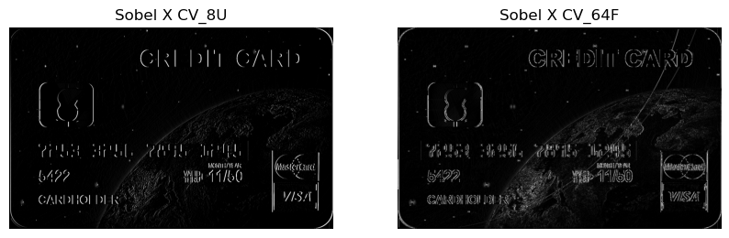
- dx =0 , dy = 1
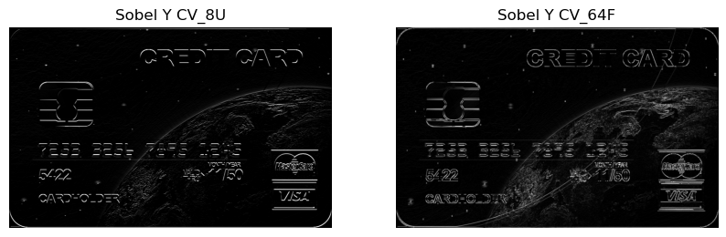
- dx =1 , dy = 1
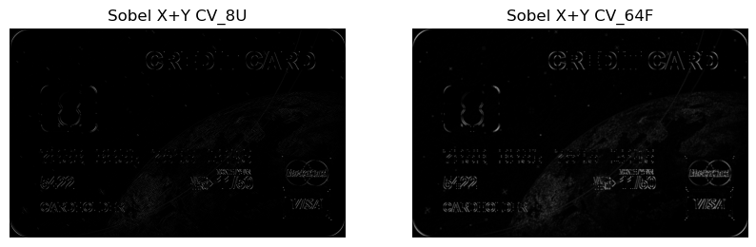
What do you notice for datatypes? Explain.
- CV_8U: The result is confined within the 0–255 range. Negative gradients become 0, and strong positive gradients become 255. Often edges are “washed out” if the gradient values are large, or important details get lost because of truncation.
- CV_64F: Gives a floating-point result which can represent both positive and negative derivative values. We can see negative pixel values directly. For visualization, we took the absolute value, so edges show up positive, and then converted to 8-bit.
What do dx and dy show? Explain.
- dx=1, dy=0: Shows derivative in the x-direction, emphasizing vertical edges.
- dx=0, dy=1: Shows derivative in the y-direction, emphasizing horizontal edges.
- dx=1, dy=1: Combines both x and y derivatives, capturing diagonal edges and edges that have both horizontal and vertical components.
- Compare the results of Sobel operator with the Canny edge detector. Experiment with different low and high threshold values and display two samples here. How is threshold changing the results?
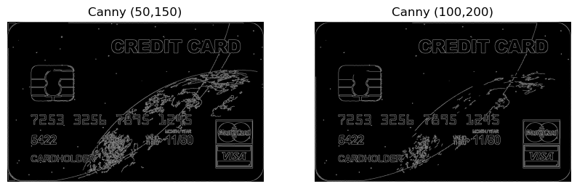
- Lower thresholds mean the detector is more sensitive. It will pick up more edges, as well as more noise.
- Higher thresholds will find only the stronger edges and ignore weaker ones. It will pick up fewer edges, as well as less noise, so that we have cleaner results.
- Explain how is the Canny map different from the Sobel map?
- Canny performs the following:
- Gaussian smoothing
- Intensity gradient calculation
- Non-maximum suppression, which makes edges thin
- Hysteresis thresholding, which connects edge segments or discards them based on thresholds
Canny edges are typically thinner and more continuous, and can be less noisy.
- Sobel is just a gradient-based filter that highlights regions of high spatial derivative. It does not include non-maximum suppression or hysteresis, so the result can be a thicker outline of edges and typically more noise in the output.

Part II: Line & Circle Detection
Create a program (save as Assignment3_2). Include code to:
- Open ‘Chess_Board’ and convert it to grayscale. Paste the result here.
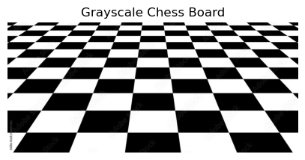
- Use Canny edge detector to detect edges. Paste the result here. What hyperparameters did you use for Canny?
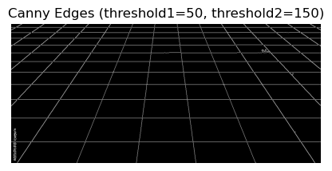
I chose (threshold1 = 50, threshold2 = 150) for hyperparameters.
- Use either the standard or probabilistic Hough transform (OpenCV: Hough Line Transform) to detect lines in the above image. Implement a loop to increment the threshold and visualize the lines on the image for various threshold values. Paste the resulting images with lines for three different threshold values.
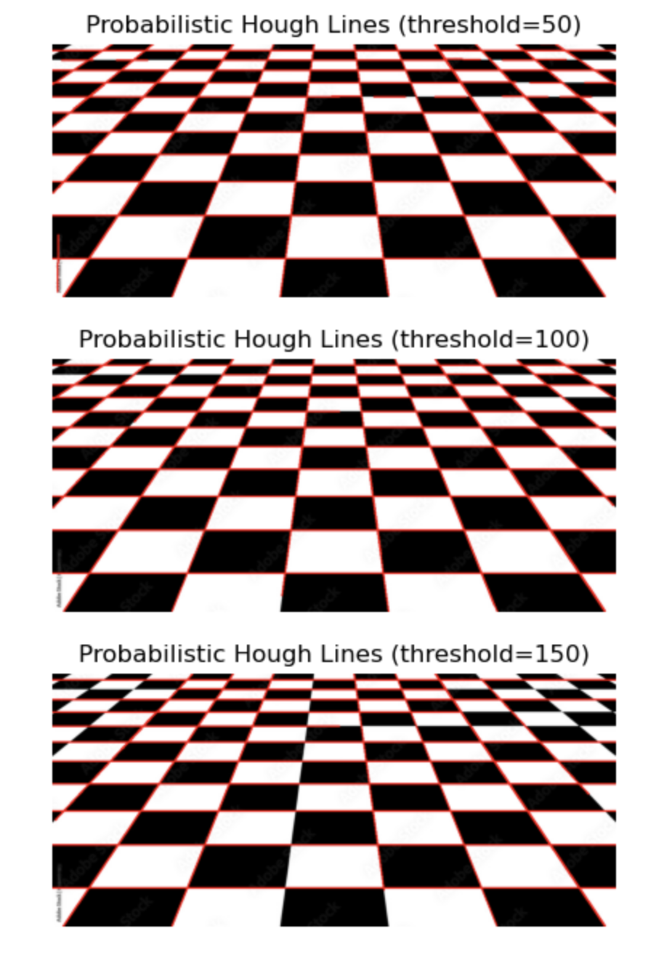
- Explain what threshold does.
Threshold is the minimum number of votes needed to decide that a line is present. A lower threshold will detect more lines including weaker lines or possibly noise, while a higher threshold demands more votes to declare a line, leading to fewer and more prominent lines.
- Use Hough transform (OpenCV: Hough Circle Transform) to detect circles in the ‘Coins’ image. Implement a loop to visualize the circles detected on the image for various values of minDist and maxRadius. Paste at least four of the resulting images with circles.
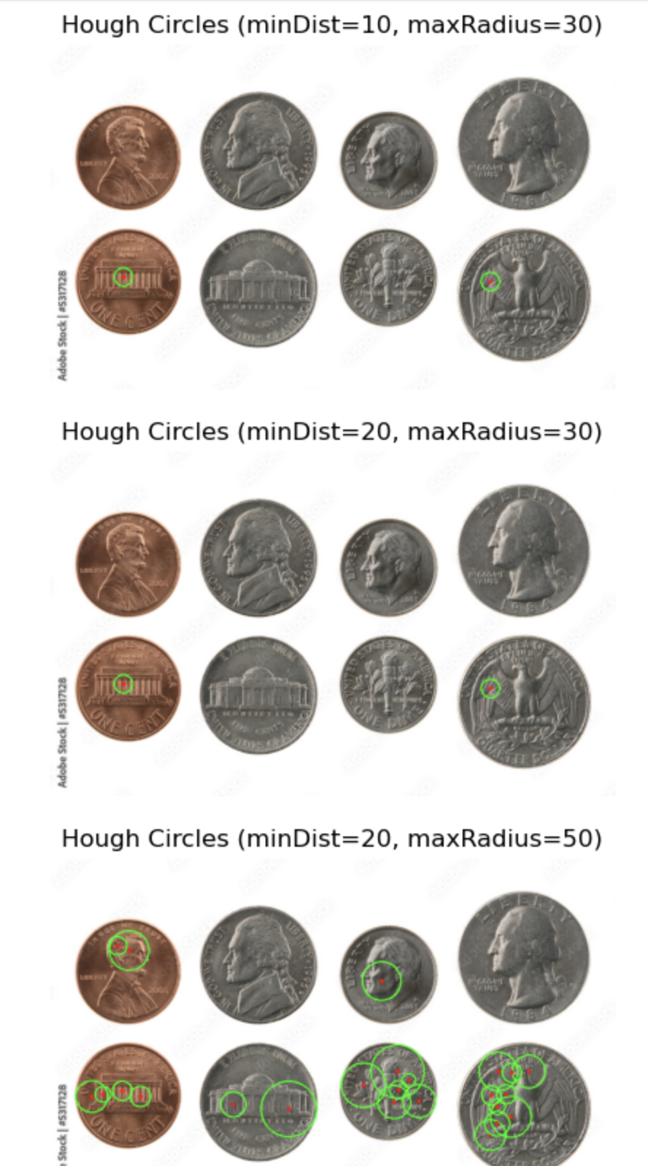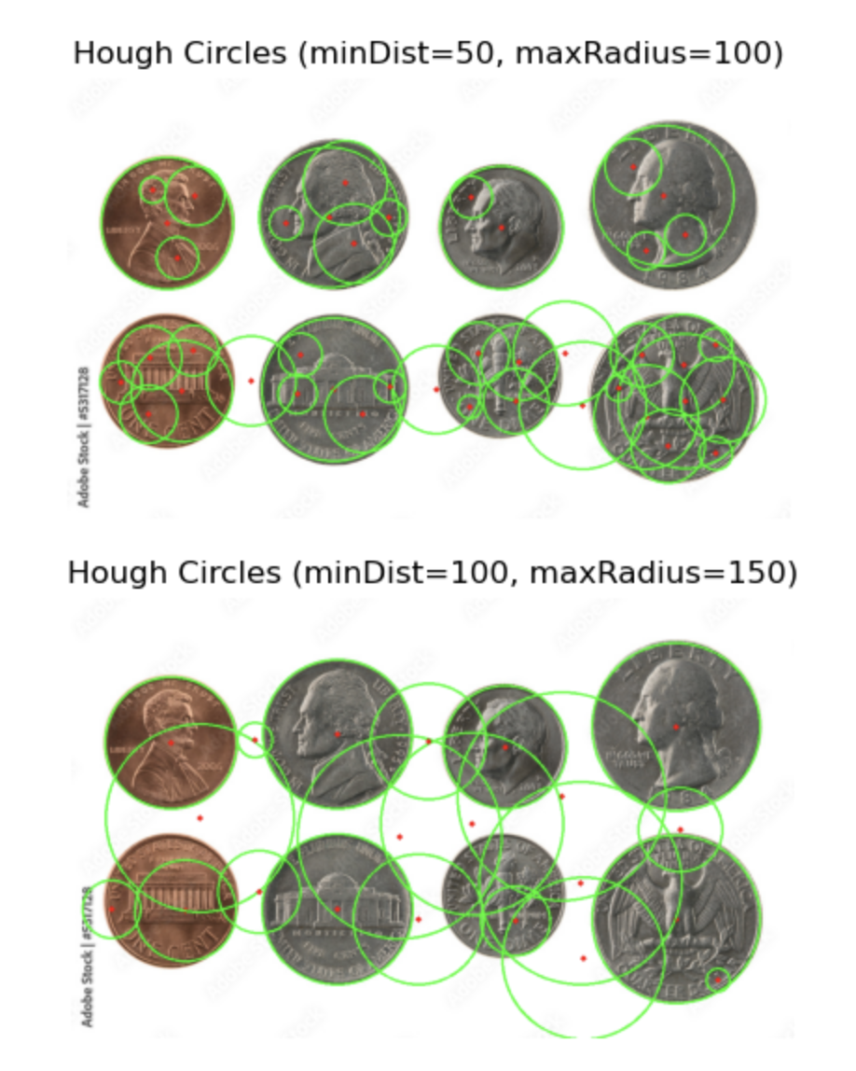
- In your words, explain how would parameters in cv.HoughCircles() change the result? Choose 3 parameters for this part.
- minDist: Minimum distance between the centers of the detected circles. A small minDist might lead to detecting multiple small circles clustered in one coin area, which is over-detection. A large minDist might cause it to miss some circles that are close to each other, which is under-detection.
- minRadius and maxRadius: The range of circle sizes to detect. If minRadius is too large, small circles won’t be detected. If maxRadius is too small, large circles won’t be detected.
- dp: The inverse ratio of the accumulator resolution to the image resolution. If dp = 1, the accumulator has the same resolution as the input image. If dp > 1, the accumulator resolution is lower. A larger dp can speed up processing but might reduce accuracy.

Part III: Matching Using Local Features
Create a program (save as Assignment3_3). Include code to:
- Open ‘boat1’ and ‘boat3’.
- Use ORB to detect and describe local features for the above images. Match features for the top 15 and the top 20 matches, using:
  - BFMatcher
  - FlannBasedMatcher
Paste results here.
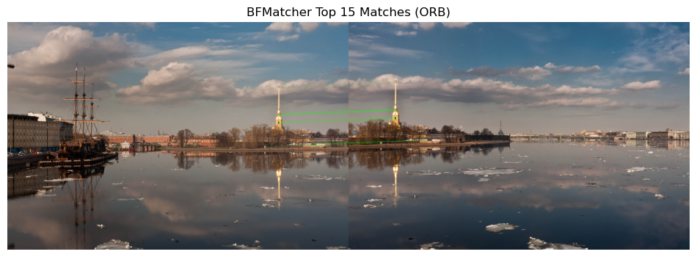
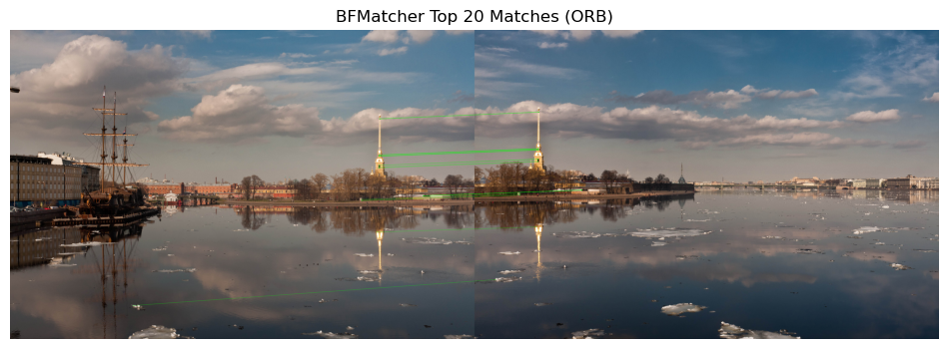
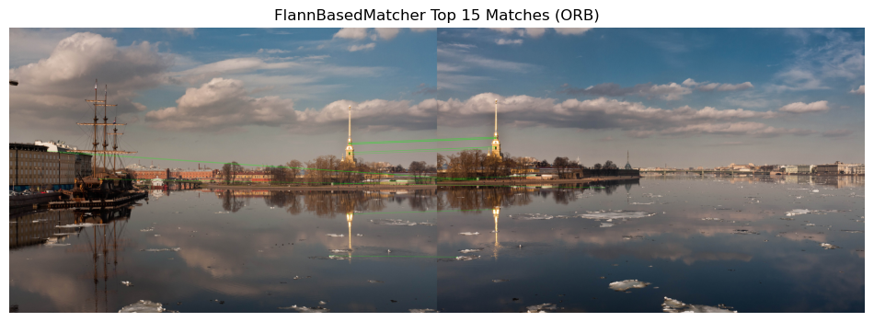
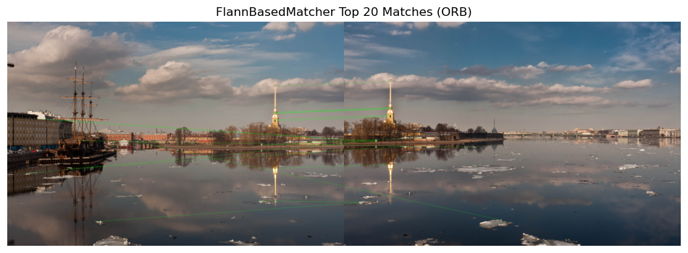
- How are keypoints matched? What is the difference between these two matchers? Which one performs better, and why?
- Both BFMatcher and FlannBasedMatcher compare the descriptor of each keypoint in the first image to the descriptors of keypoints in the second image. They then select the best match based on the smallest distance metric.
- BFMatcher checks each descriptor from image1 against every descriptor in image2 to find the best match. It’s straightforward but can be slower for large descriptor sets. FlannBasedMatcher uses more sophisticated data structures for approximate nearest neighbor search, usually faster on large datasets but might have slightly less accurate matches.
- BFMatcher performs better, since Flann has a few bad matches. With small numbers of keypoints, BFMatcher might be perfectly fine or even faster. With large descriptor sets, Flann can be significantly faster. BF can be more direct since it’s brute force. Flann might have approximate matches, but typically it’s still highly effective and faster.
- Rotate ‘boat3.jpg’ by 20 degrees counterclockwise around its center. Repeat feature matching between the rotated image and ‘boat1.jpg’ selecting the top 10 matches. Show the matches using FlannBasedMatcher.
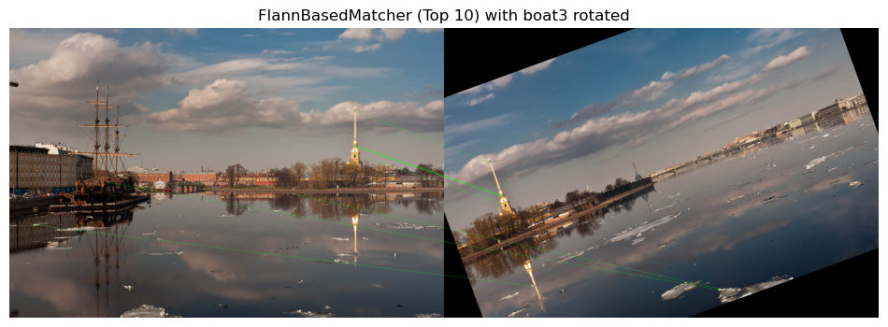
- How does the rotation affect the matching? Explain.
Most of the matches are the same as before when it’s not rotated. ORB is typically rotation-invariant in principle, so it still matches most of the keypoints.
- (Optional) Use SIFT descriptors to match features between the images. Utilize a FlannBasedMatcher and apply Ratio Matching to filter the matches. Compute the homography matrix using the matched keypoints (a minimum of four corresponding point pairs is required between the two images). Warp one image to align with the other using the computed homography matrix.
You can further attempt to blend and stitch the boat images from the Assignment3_Files folder to create a single panorama. Note that OpenCV's cv2.Stitcher class (OpenCV: Images stitching) provides built-in functions for panorama creation. It handles feature detection, homography estimation, image warping, and blending automatically. Once completed, paste the result here.
[Images obtained from opencv_extra/testdata at 4.x · opencv/opencv_extra · GitHub]

Part IV: Template Matching
Create a program (save as Assignment3_4). Include code to:
- Open ‘Chess_Pieces’ as query image, and ‘King’ as template image.
- Use matchTemplate and TM_SQDIFF measure to find the best match location. Draw a rectangle around the matching area in the query image. Additionally, display the matching space. Paste the results here.
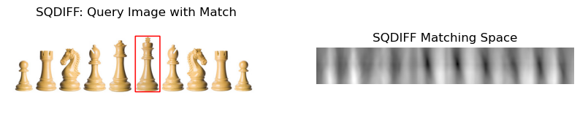
- Repeat matching, using TM_CCORR measure this time. Similarly, paste the results here.
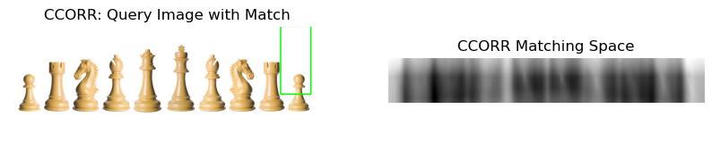
- How are the two results and the matching spaces different? Explain.
TM_SQDIFF correctly found the match and TM_CCORR did not. TM_SQDIFF produces lower values at the best match location, darker in the matching space, hence the minimum location in the result is the best match. TM_CCORR produces higher values at the best match location, brighter in the matching space, hence, the maximum location in the result is the best match. Visually, we see a bright spot in the result image for CCORR near the matched region, but for SQDIFF, the matched region is the darkest spot. Correlation methods often handle brightness offsets more perfectly, especially if the lighting between the query and template are not the same. TM_SQDIFF is apt for for exact matches.

